CO21BTECH11002

Aayush Kumar

Assignment – Eigenvalues

Algorithm:

1) Using Lagrange Polynomial:

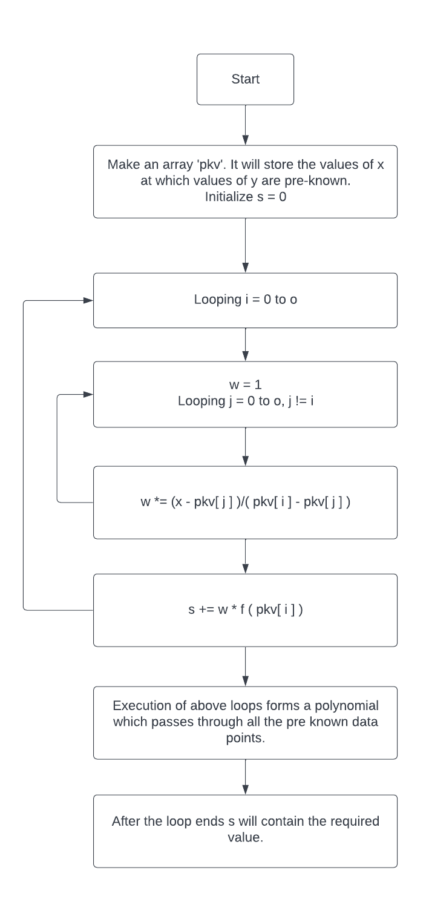

2) Using Newton’s Polynomial:

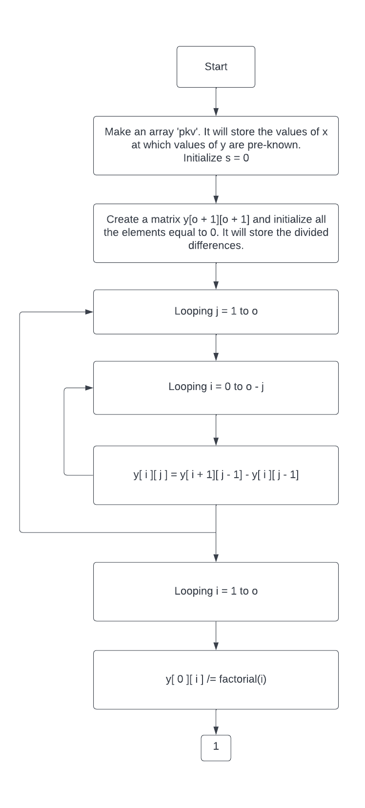

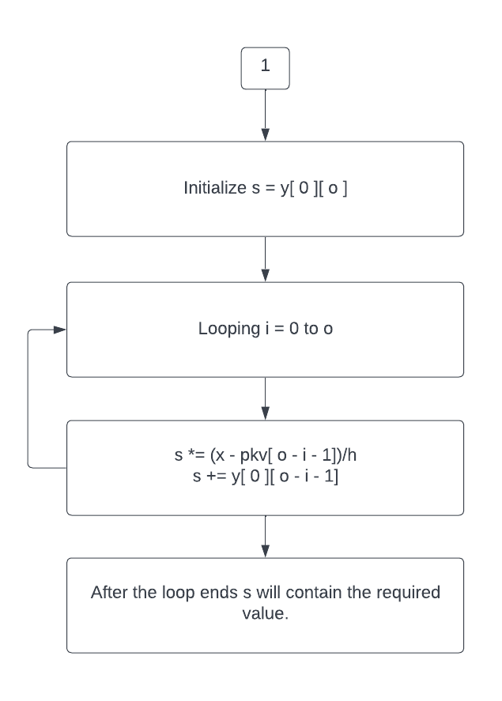

Output:

$Both the polynomials have order 'o' and passes through (o+1) given data points.$

$In fact being expanded in powers of x, Newton polynomial is the same as the Lagrange$

$$polynomial. Therefore, the error of Newton interpolation is also the same as error$$

$of the$ $Lagrange interpolation. The difference between Newton and Lagrange$

$interpolating$ $polynomials lie only in the computational aspect. The advantage of$

$Newton interpolation$ $is the use of nested multiplication and relative easiness to$

$add more data points for$ $higher-order interpolating polynomials.$

|  |  |  |  |  |  |
| --- | --- | --- | --- | --- | --- |
| x | Method | Order | h | Value | Error |
| 1.53 | Lagrange Interpolation | 2 | 0.1 | 2.400892633 | -0.0044004770 |
|  |  |  | 0.05 | 2.4007770199 | -0.0005582266 |
|  |  | 4 | 0.1 | 2.4007638942 | -0.0000114947 |
|  |  |  | 0.05 | 2.4007636273 | -0.0000003774 |
|  | Newton Interpolation | 2 | 0.1 | 2.400892633 | -0.0044004770 |
|  |  |  | 0.05 | 2.4007770199 | -0.0005582266 |
|  |  | 4 | 0.1 | 2.4007638942 | -0.0000114947 |
|  |  |  | 0.05 | 2.4007636273 | -0.0000003774 |
| 2.01 | Lagrange Interpolation | 2 | 0.1 | 3.9929707066 | -0.0038845345 |
|  |  |  | 0.05 | 3.9928352800 | -0.0004927763 |
|  |  | 4 | 0.1 | 3.9928160095 | -0.0000101470 |
|  |  |  | 0.05 | 3.9928156176 | -0.0000003331 |
|  | Newton Interpolation | 2 | 0.1 | 3.9929707066 | -0.0038845345 |
|  |  |  | 0.05 | 3.9928352800 | -0.0004927763 |
|  |  | 4 | 0.1 | 3.9928160095 | -0.0000101470 |
|  |  |  | 0.05 | 3.9928156176 | -0.0000003331 |
| 2.76 | Lagrange Interpolation | 2 | 0.1 | 8.0977857944 | -0.0034901476 |
|  |  |  | 0.05 | 8.0975390309 | -0.0004427460 |
|  |  | 4 | 0.1 | 8.0975039178 | -0.0000091168 |
|  |  |  | 0.05 | 8.0975032038 | -0.0000002993 |
|  | Newton Interpolation | 2 | 0.1 | 8.0977857944 | -0.0034901476 |
|  |  |  | 0.05 | 8.0975390309 | -0.0004427460 |
|  |  | 4 | 0.1 | 8.0975039178 | -0.0000091168 |
|  |  |  | 0.05 | 8.0975032038 | -0.0000002993 |